- Squares and square roots
1. Evaluate without using tables or calculators
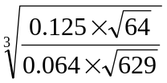 (4mks)
2. Evaluate using reciprocals, square and square root tables only.
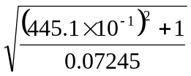 (3mks)
3. Using a calculator, evaluate 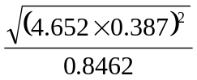 (3mks)
(Show your working at each stage)

4. Use tables of reciprocals and square roots to evaluate
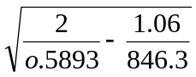 (3marks)

5. Use tables to find;
a) i) 4.978²
ii) The reciprocal of 31.65
b) Hence evaluate to 4.S.F the value of
4.978² – ¹/_{31.65}

6. Use tables of squares, square roots and reciprocals to evaluate correct to 4 s.f
3 - 2
2
0.0136 (3.72)

7. Without using mathematical tables or calculator, evaluate: 153 x 1.8 giving
your answer in standard form 0.68 x 0.32

